**Lesson 5 Demo 4**

**Integrate Ant with Jenkins**



Steps to be followed:

1. Create a GitHub repository
2. Add build.xml file to the repository
3. Set the Global Tool Configuration
4. Integrate Ant with Jenkins

**Step 1: Create a GitHub repository**

* 1. Open the browser.

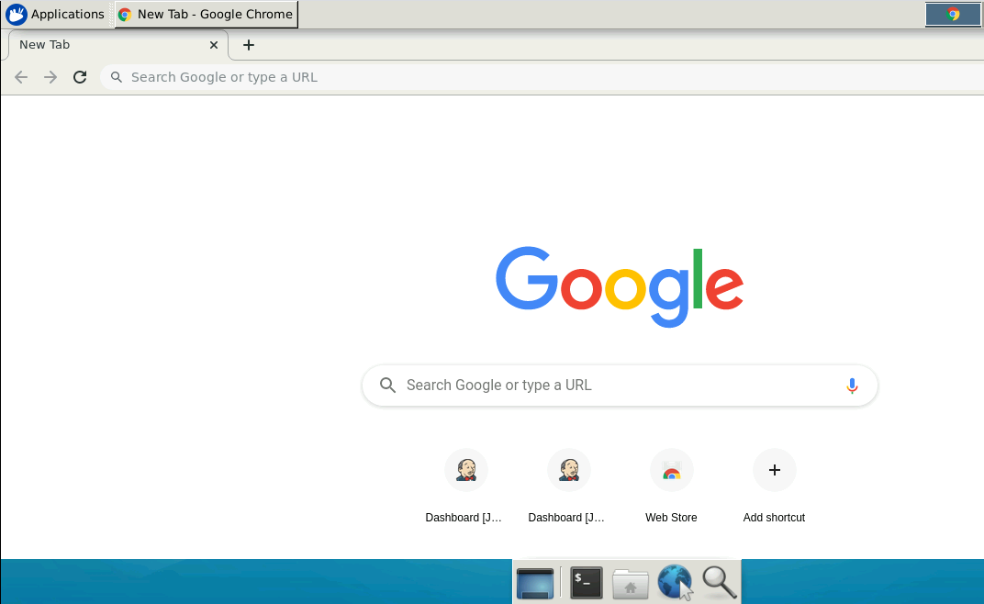

* 1. Go to <https://github.com/> link.

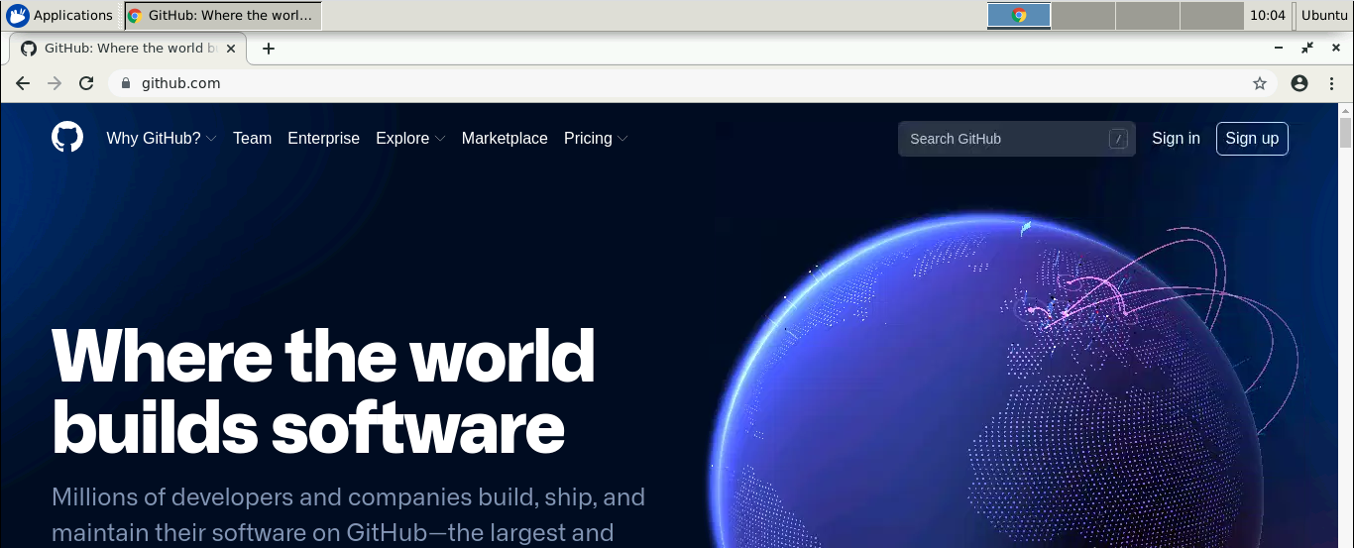

* 1. Click on **Sign in** and enter the credentials of your GitHub account to login.

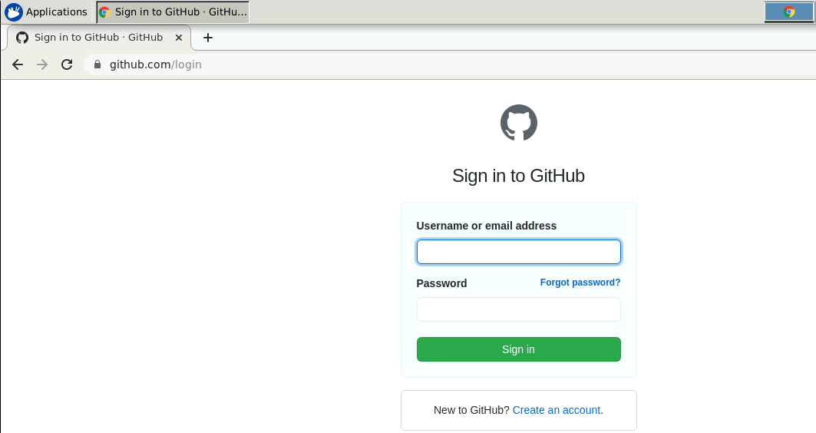

* 1. Click on **+** symbol and select **New repository**.

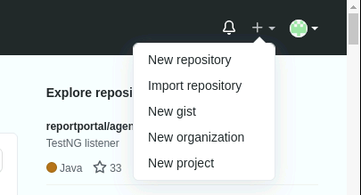

* 1. Provide the repository name.

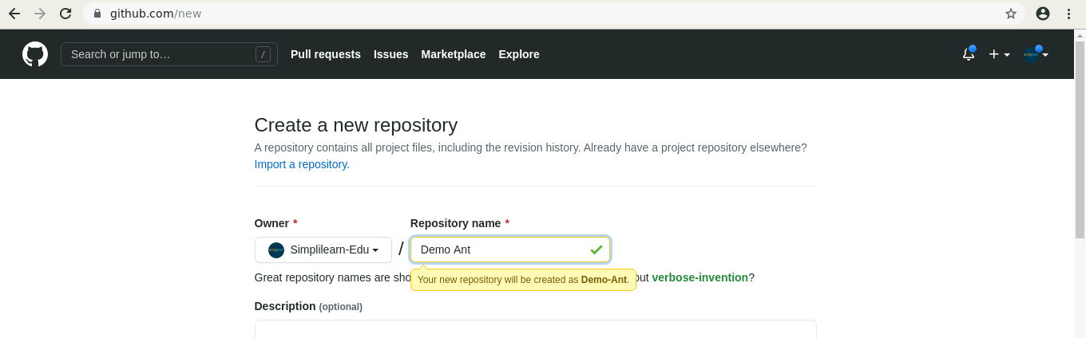

* 1. Select the check box of **ADD a README file** and click on **Create repository**.

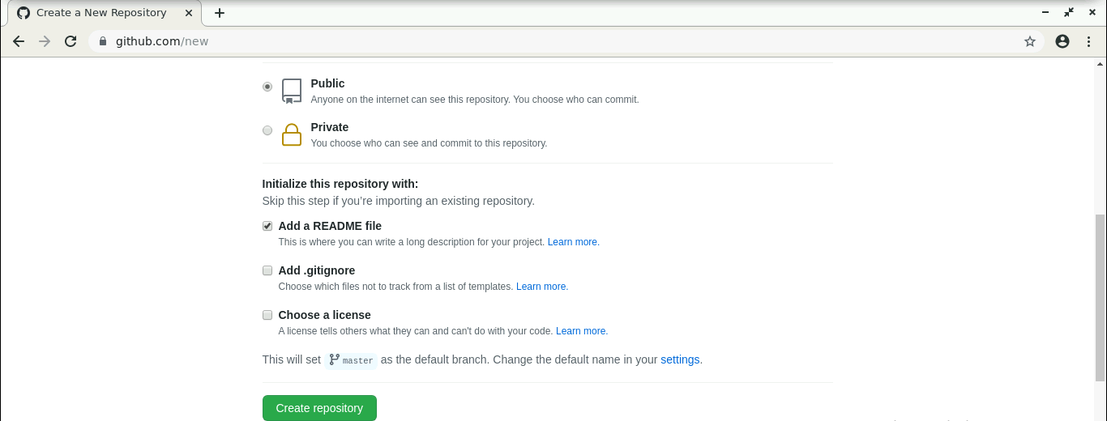

* 1. Click on **Code**.
  2. Click on **HTTPS**.
  3. Copy the repository URL.

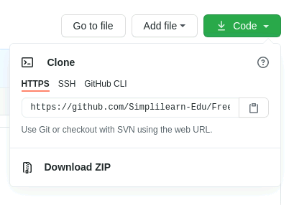

**Step 2: Add build.xml file to the repository**

* 1. Open the terminal.
  2. Run ***mkdir helloworld*** to create a directory.
  3. Navigate to the hello-world directory. Run ***cd helloworld*** command.
  4. Run ***vi******build.xml***to open the java file in a text editor.



2.5 Paste the code below into the file:

***<?xml version="1.0"?>***

***<project name="Hello World Project" default="info">***

***<target name="info">***

***<echo> Hello World - Welcome to Simplilearn</echo>***

***</target>***

***</project>***

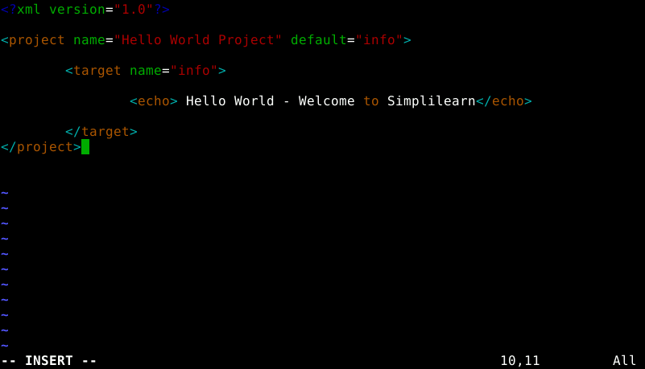

* 1. Save the file and exit the text editor.
  2. Run ***git init*** command.
  3. Run ***git add .*** command.
  4. Run ***git commit -m “Add new files”*** command.

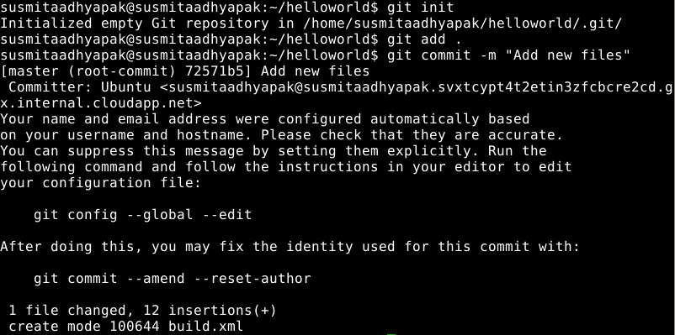

* 1. Run ***git remote add origin <Repository_URL>*** command.
  2. Run ***git push -u origin master*** command.



**Step 3: Set the Global Tool Configuration**

* 1. Open the browser and go to **Jenkins dashboard** by typing **localhost:8080** in your browser.

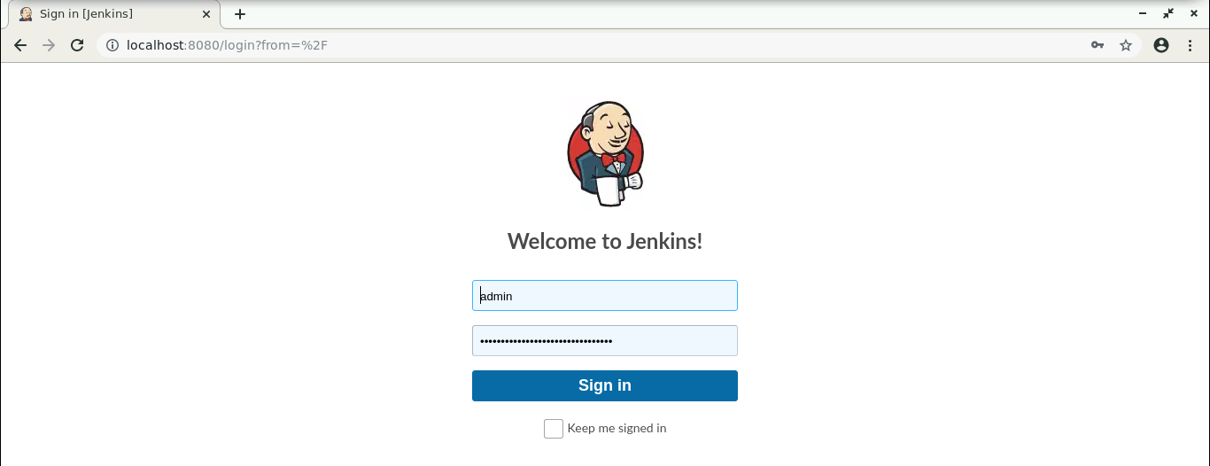

* 1. Provide the credentials and click on **Sign in**.
  2. Go to Jenkins **Dashboard**, click on **Manage Jenkins**. From the list of options, choose **Global Tool Configuration**.

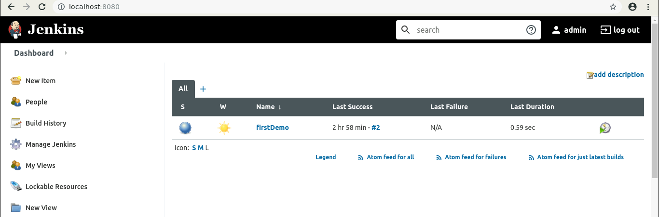

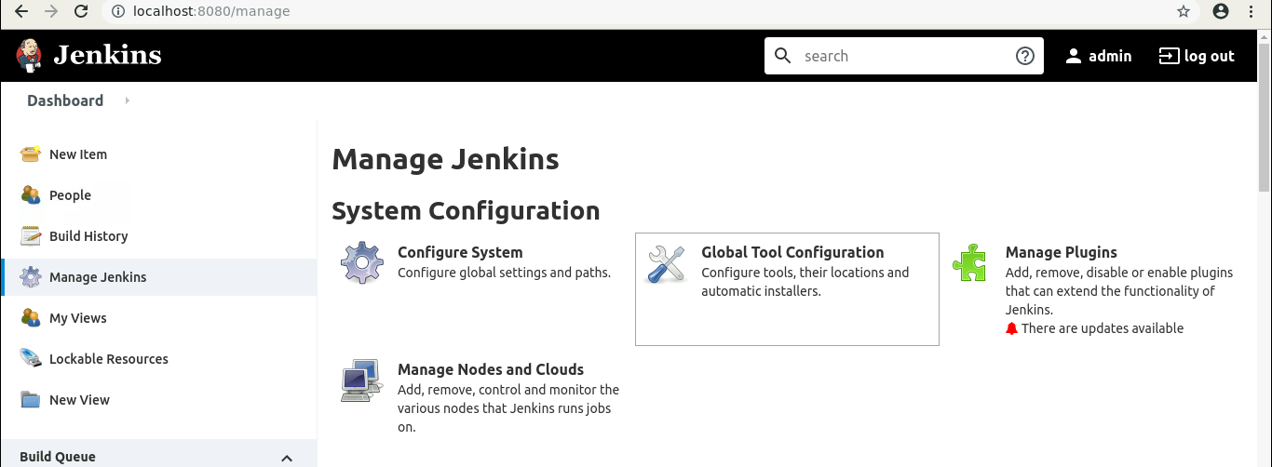

* 1. Click on **Add Ant**, provide the **Name**, and select the version you want to install. And check the Install automatically checkbox*.*

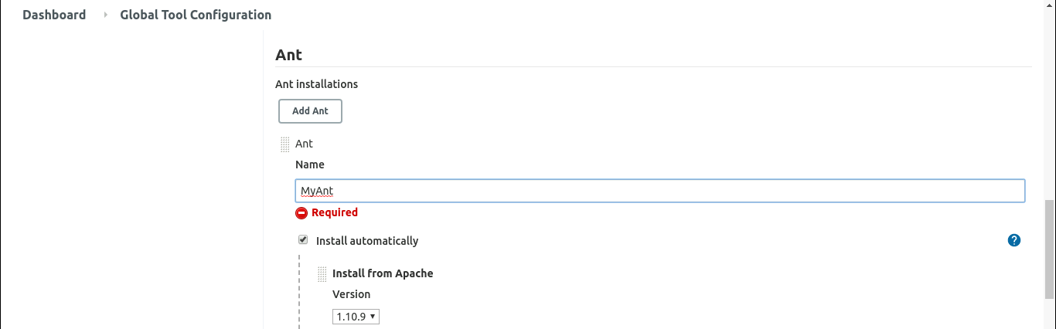

* 1. Click on **Save**.

**Step 4: Integrate Ant with Jenkins**

* 1. Click on **New Item** in the Jenkins dashboard.

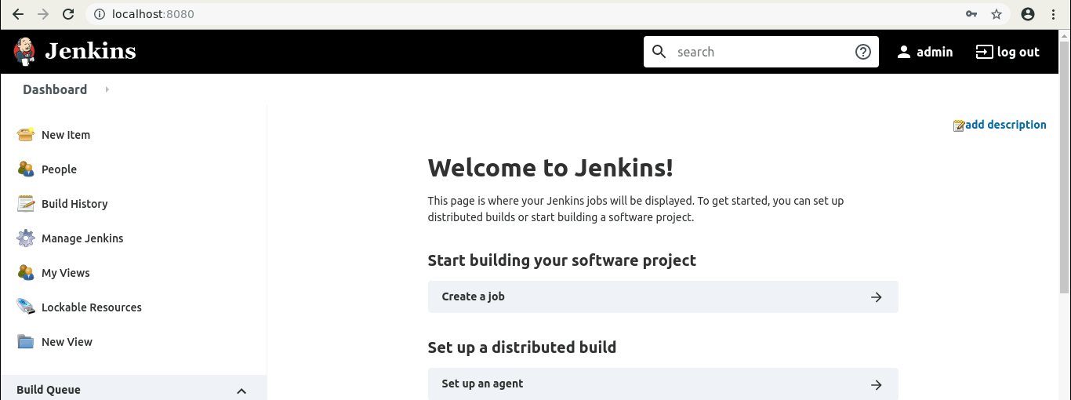

* 1. Enter a name for your project.
  2. Select **Freestyle project** as the build job type.

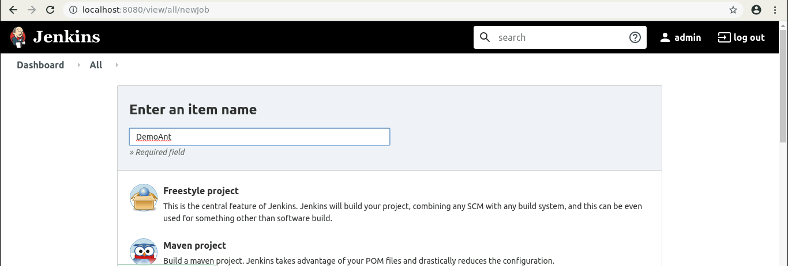

* 1. Click on **OK**.
  2. Scroll down to the **Source Code Management section** and select **Git**.
  3. Enter the repository URL.

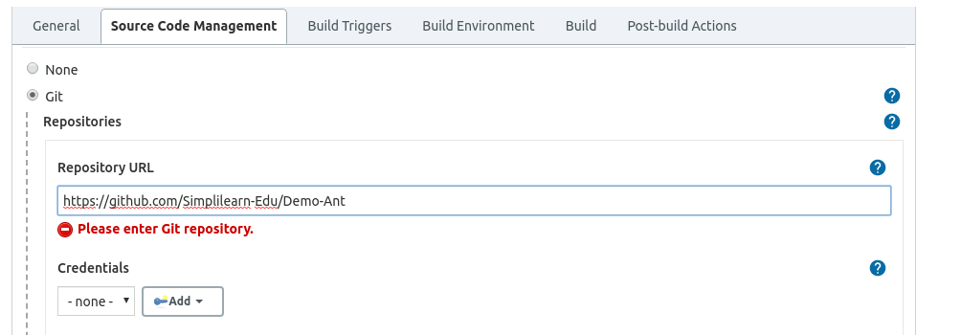

* 1. In the **Build** section, click on the **Add build step** option and select **Invoke Ant**.

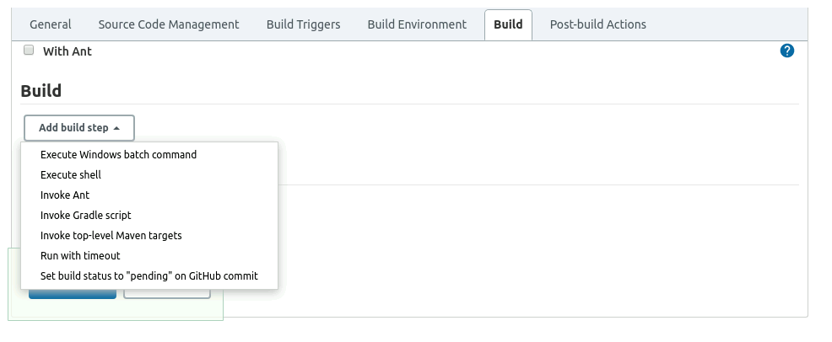

* 1. Select the **Ant version** you want to work on.

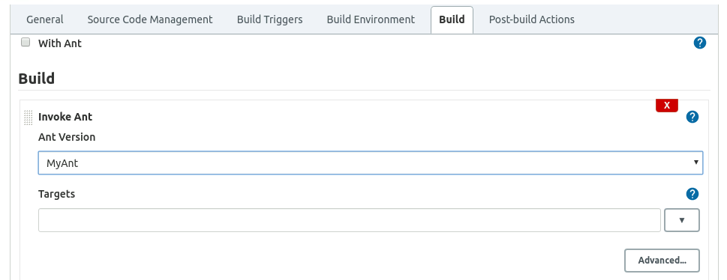

* 1. Click on **Save**.
  2. Click on **Build Now**.

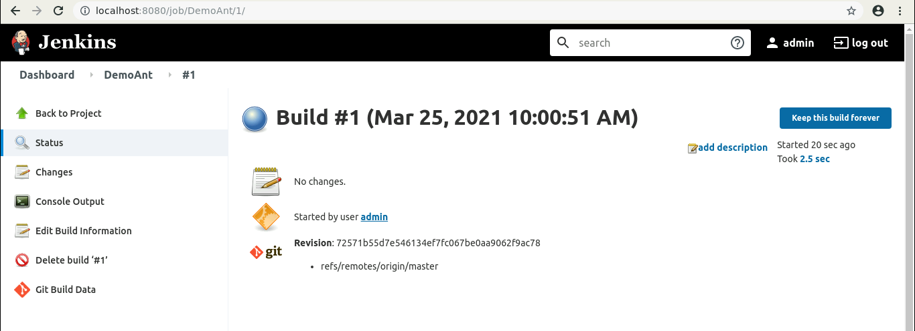

* 1. Click on the **Build History**to view the build results.
  2. Click on the **Console Output** to view the build logs.